# Content Fragments

Creating Content Fragments in AEM involves:

1. Creating a Content Model (Template/Model)
2. Creating a Content Fragment (Content)

# **Why should one use a Content Fragment?**

As we know, in a professional setup, most of the times, content is authored by editorial staff and then it is layout by a production layout specialist. Content fragments allows authors to write content without having to worry about the layout. While writing one should write independent of the layout. In addition, one should think about how the same message gets conveyed on multiple channels – that’s all what Content Fragment authoring is all about.

# Creating a Content Model (Template/Model)

1. Use configuration browser, create a new configuration selecting content fragments CF_Config
2. Go to <host>/assets.html/content/dam , create a new folder (CF_Folder) and navigate to cloud services tab in folder CF_Folder properties
3. In the path browser, select the recently created CF_Config and save it
4. Once the above step is done, we see content Fragment Models comes up at Tools>Assets
5. Click on content Fragment Models and create a new model (CF_Model) with various input fields available and save
6. Navigate to Tools>Assets>Create (Content Fragment), we see the CF_Model will be available along with the OOTB templates for creating content fragments

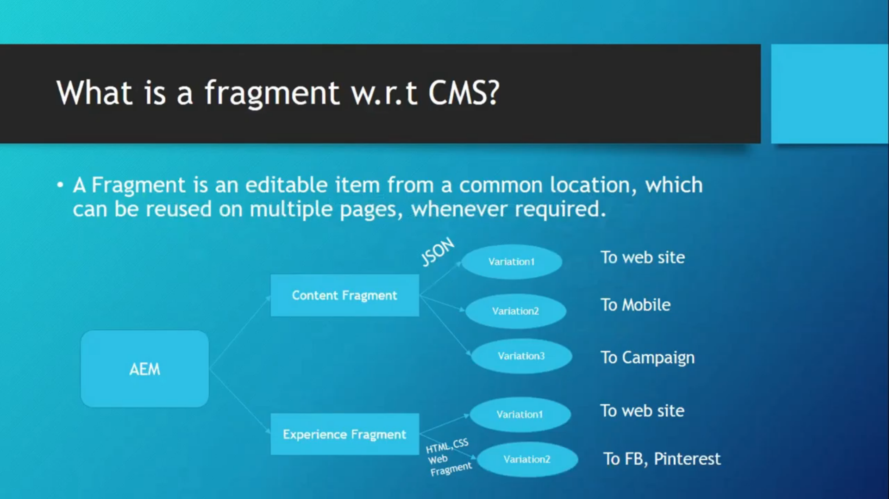

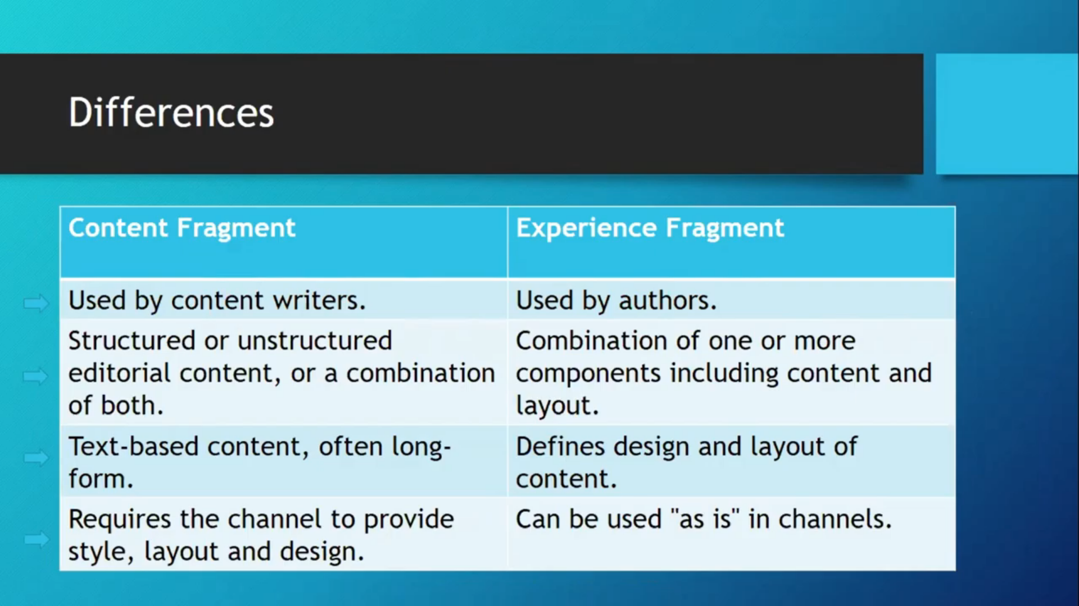

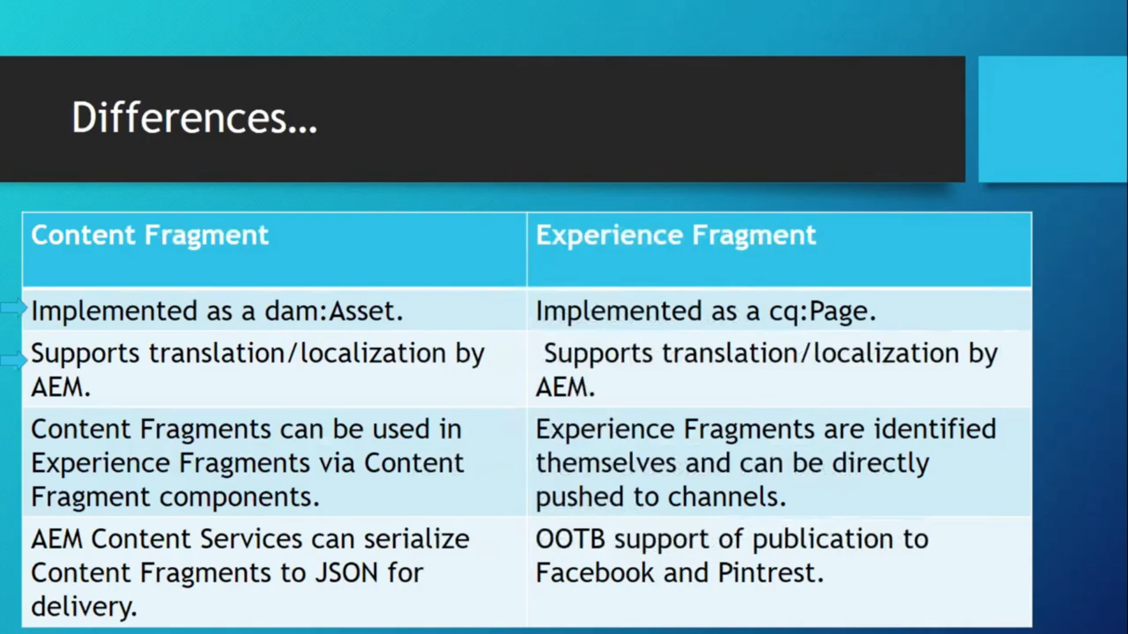

Useful Resources:

Steps for creating new content fragment templates in assets console 🡪<https://with-example.blogspot.com/2019/10/content-fragments-in-aem-caas-in-aem.html>

Diff b/w ContentFragments(CF) & ExperienceFragments(XF)🡪 <http://myaemlearnings.blogspot.com/2019/10/experience-fragments-and-content.html>

<https://www.aemquickstart.in/2020/03/create-content-fragment-in-aem.html>